

# Team member

Ben Wilson

Chi Wong

Devin Lorenzen

Edward Sayers

Hanjae Noh

Capstone 2015

The following document details the purpose of GPS Jamming signal detector and the relevant information is provided to give background knowledge into present prior research efforts in the field. A project plan(schedule) is specified, detailing a series of tasks that will be performed by capstone team.

Table of Contents

Team member 1

Purpose - GPS Jamming detection 3

Background - Jamming 4

Marketing Requirements 5

Must: 5

Should: 5

May: 5

Design specification 6

Works Cited 7

Revision Table 8

# Purpose - GPS Jamming detection

Many trucking companies make use of GPS tracking devices in order to reduce fuel cost, improve driver behavior and increase security and safety. However, there are unscrupulous individuals who want to jam their GPS signal. There are simple ways to jam the GPS signal that is being received by the tracking device located on the truck such as GPS jamming gadgets, metal shields, GPS spoofing gadgets and mobile phone jammer. Whether intentional or inadvertent, jamming GPS signals poses a significant risk to our daily lives. There are couple of examples that highlighted by GPS Jamming(San Diego Harbor in January 2007, Newark Airport in August 2013, and The Stock Market in February 2012 in the U.K.).

[1] Jeff Coffed. (2014, Feb). "The threat of GPS Jamming. â€ EXELIS. [Online]. pp. 6. Available: http://www.exelisinc.com/solutions/signalsentry/Documents/ThreatOfGPSJamming_February2014.pdf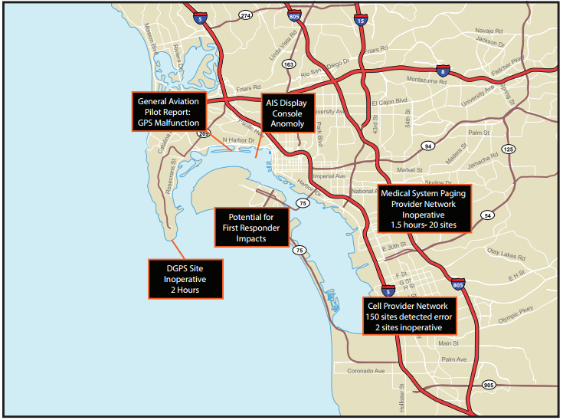

figure 1. San Diego Harbor in January 2007

GPS jammers are illegal to buy, use, or sell due to the potential for criminal or terroristic uses. To help resolve the illegal use of GPS Jammers we would like to design jammer detection when these jamming signals are being utilized.

# Background - Jamming

Most jamming techniques are divided into three major types based on bandwidth (CW, NB, and WB). Bandwidth for continuous wave (CW) jamming, is usually greater than 30KHz. Narrowband (NB) jamming is defined as any unwanted signal occupying more than one MHz of bandwidth but less than or equal to the entire ±1.023 MHz bandwidth of C/A code. Wideband (WB) jamming is defined as signals occupying the entire ±10.23 MHz bandwidth about L1.

[2] Gregory D. Rash. (1997). GPS Jamming in A Laboratory Environment. [Online]. pp. 1-4. Available:

http://www.globalsecurity.org/space/library/report/1997/labjam.pdf

There are couple of important parameters in jamming signals.

---------------------------------------

Such researched jamming techniques include;

* Continues Wave Jamming
* Pulse Jamming
* Chirp Jamming

# Constraints

* Processing speed
* Device size: Less than 8 x 8 x 4 inches
* I/Q data as an input

# Marketing Requirements

## Must:

1. Receive I/Q data
2. Determine if a civilian GPS jamming signal is present
3. Notify the user that a jammer has been detected
4. Be fast enough to notify a user that a jammer is present when the jammer is in a moving vehicle

## Should:

1. Be able to detect multiple types of jamming techniques
2. Give indication of jamming method
3. Be implemented on a FPGA
4. Determine the center frequency of the jammer
5. Be portable

## May:

1. Determine the direction of jamming signal
2. Determine the presence of a GPS spoofer
3. Determine the average signal power of jammer

# Design specification

|  |  |  |
| --- | --- | --- |
| Marketing requirements | Engineering Requirements | Justification |
| 1 | 1. The device must accept in-phase and quadrature (I/Q) data through an external interface. | The jamming signals that will be collected and used to test the device will be in a I/Q data format. |
| 2 | 1. The device must be able to detect the presence of a jamming signal in the L1 band. | The primary use of the device is the detection of a jamming signal in the civilian GPS band. |
| 4 | 1. The device needs to notify the user within 1 seconds. | Most receivers can detect a jammer from a range of 20 meters. A car traveling on a three lane highway will pass through the effective in about 1 seconds. |
| 3,5,6 | 1. Must be able to differentiate between continuous, pulse, and chirp jamming. | There are multiple type of jammers. The operator needs to clearly see what type of jamming signal is being used. |
| 7 | 1. The device should be developed on an FPGA. | FPGAs are provided by the project sponsor. |
| 8 | 1. The device should be able to detect the center frequency of the jamming signal. | Many jammers are not very precise and may affect services other than GNSS. Also, detecting the center frequency can aid in determining the variance of cheaply produced jammers. |
| 9 | 1. The device should be less than 8 x 8 x 4 inches. | The detector is likely to be used in a motor vehicle. |

# Works Cited

**There are no sources in the current document.**

Jeff Coffed, The Threat of GPS Jamming The Risk to an Information Utility, February 2014. <http://www.exelisinc.com/solutions/signalsentry/Documents/ThreatOfGPSJamming_February2014.pdf>

Gregory D. Rash, GPS Jamming in A Laboratory Environment Naval Air Warfare Center Weapons Division (NAWCWPNS). < http://www.globalsecurity.org/space/library/report/1997/labjam.pdf>.

Ryan H. Mitch, Ryan C. Dougherty, Mark L. Psiaki, Steven P. Powell, Brady W, Jahshan A. Bhatti and Todd E. Humphreys, Signal Characteristics of Civil GPS, 2011.

< http://gps.mae.cornell.edu/Paper_C3_3_ION_GNSS_2011b.pdf>.

Logan scott, introduction to GPS interference and Mitigations, January 2015

# Revision Table

|  |  |  |
| --- | --- | --- |
| Version | Changes Made | Editor |
| 1 | Created First Draft | Hanjae |
| 2 | Added Revision Table Added Member Names  Edited Formatting  Added Table of Contents  Added Citation page | Devin |
| 3 | Constraints | Hanjae |
|  |  |  |
|  |  |  |
|  |  |  |